

The New York Association of Hostage Negotiators will be hosting their 11th Annual Conference in Rochester, New York from May 18-20, 2016 at the Holiday Inn Downtown Hotel, 70 State Street, Rochester.

This year, NYAHN will return to its Hostage Negotiator Seminar format that will provide for presentations from experts in the field of Negotiations from all over the United States and Canada.

The cost for the training is $229 per person if registered by April 15, 2016. After April 15, the cost of registration is $299. The hotel has provided a government rate of $92 per night by using reservation code HNC. Contact President Sam Farina via email at ssfarina@aol.com for registration and information.

Confirmed for the conference thus far is:

Doctor Wayman Mullins of the Texas State University and co-author of the book on Crisis Negotiations.

Lieutenant Jack Cambria (retired) of the NYPD Hostage Negotiations Team

Dr. Jeff Thompson of NYPD and member of the Hostage Negotiations Team

Timothy Mahar, MS from Syracuse University – Improvisation and Negotiations

Sergeant Daniel Oblinger – Wichita Police Department – Future of Negotiations

Brian Herritt – Negotiating with an Autistic Person – Effective Communication

Case Studies:

Sergeant Harry Drucker – Los Angeles County Sheriff’s Office

Lieutenant William Hogewood (retired) – Prince George’s County Police Department

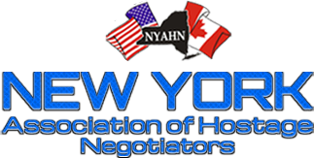
Much more to add to the agenda.

