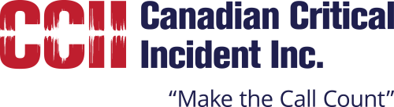

NYAHN/CCII Training Seminar 2016

Tuesday, March 01, 2016
7:00 am to 8:00 am | Registration
8:00 am to 8:30 am | Opening Remarks – NYAHN President San Farina, CCII President Tom Hart
8:30 am to 10:30 am | Phil Gurski - former senior strategic analyst at CSIS specializing in Al Qaeda, Presenting "Homegrown Islamist violent extremism in Canada and the US: what we know about the threat"
10:00 am to 10:15 am | Break
10:15 am to 11:45 am | Ottawa P.S. Insp. Mike Maloney – Presenting the Parliament Hill Shooting and murder of Canadian Forces member Cpl. Nathan Cirillo
11:45 am to 12:00 pm  12:00 pm to 1:00 pm | Special Achievement Award for Lt. Jack Cambria presented by CCII  Lunch
1:00 pm to 2:30 pm | New York City P.D, Detective Jeff Thompson, Ph.D. – Presenting his research relating to crisis negotiations during terrorist incidents
2:30 pm to 2:45 pm | Break
2:45 pm to 3:45 pm | New York City P.D, Detective James Shanahan – Presenting techniques and tactics for hostage negotiators
3:45 pm to 4:00 pm | Closing Remarks
 | End of Day

